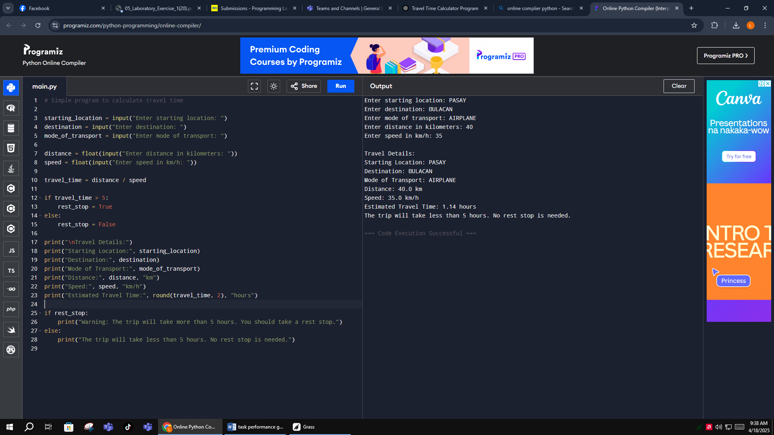

# Simple program to calculate travel time

starting_location = input("Enter starting location: ")

destination = input("Enter destination: ")

mode_of_transport = input("Enter mode of transport: ")

distance = float(input("Enter distance in kilometers: "))

speed = float(input("Enter speed in km/h: "))

travel_time = distance / speed

if travel_time > 5:

rest_stop = True

else:

rest_stop = False

print("\nTravel Details:")

print("Starting Location:", starting_location)

print("Destination:", destination)

print("Mode of Transport:", mode_of_transport)

print("Distance:", distance, "km")

print("Speed:", speed, "km/h")

print("Estimated Travel Time:", round(travel_time, 2), "hours")

if rest_stop:

print("Warning: The trip will take more than 5 hours. You should take a rest stop.")

else:

print("The trip will take less than 5 hours. No rest stop is needed.")